**Fortress Defense Installation Routine**

Generate .Jar File (Eclipse)

1. Switch to the master branch.
2. Right click on the project and click Export.  
   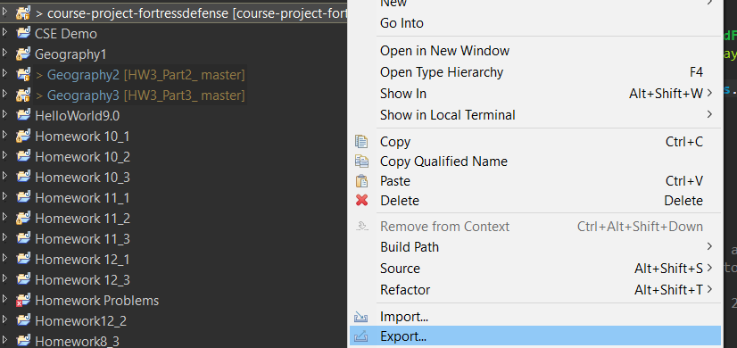
3. Under the Java folder, select JAR file and click Next.  
   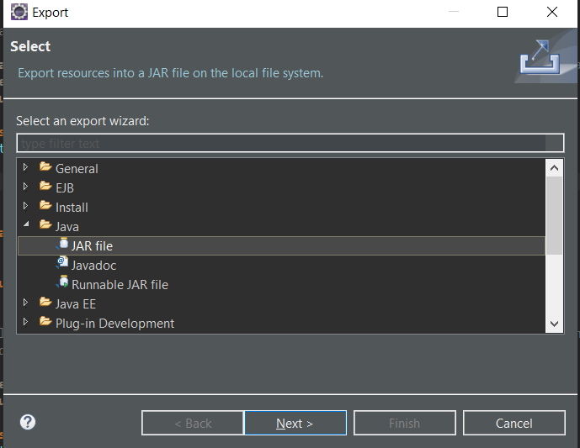
4. Ensure that the src folder, export generated class files and resources, and java source files and resources, and compress the contests of the JAR file are all checked. Select the export destination and click Next.  
   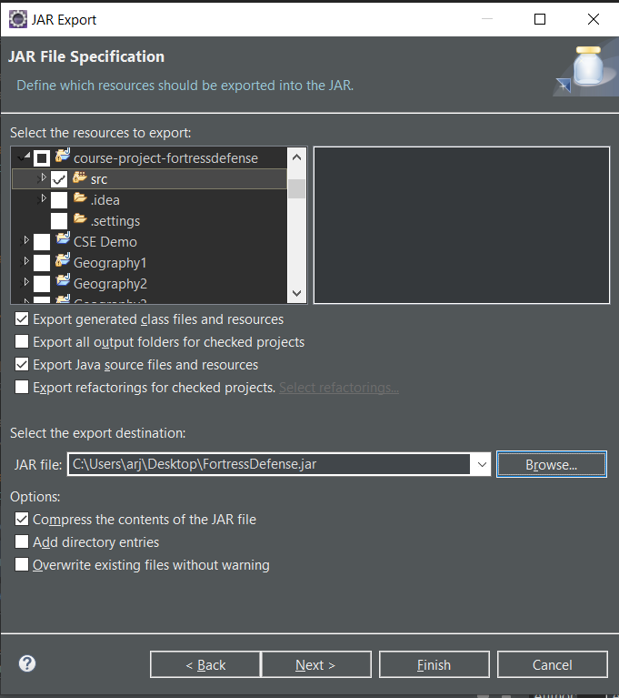
5. Ensure that export class files with compile errors and export class files with compile warnings are checked.  
   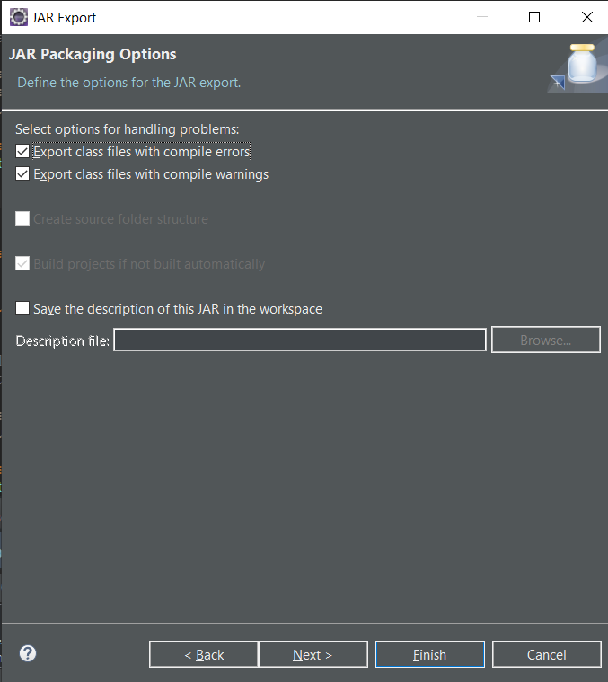
6. Ensure that the manifest specification matches the picture below. To select the main class, click Browse and select Driver. The main class should be “gui.Driver”. Click Finish.  
   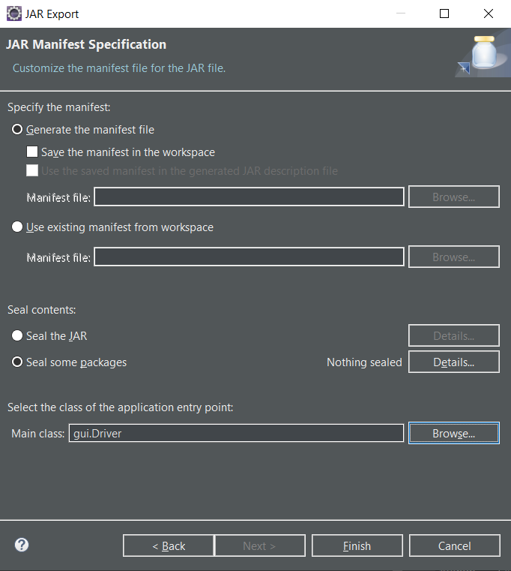

Convert .Jar file to .exe file using Launch4j

1. Open Launch4j and click the folder to open a configuration file.  
   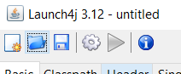
2. Find setup.xml file under setup folder in the fortress defense repository.

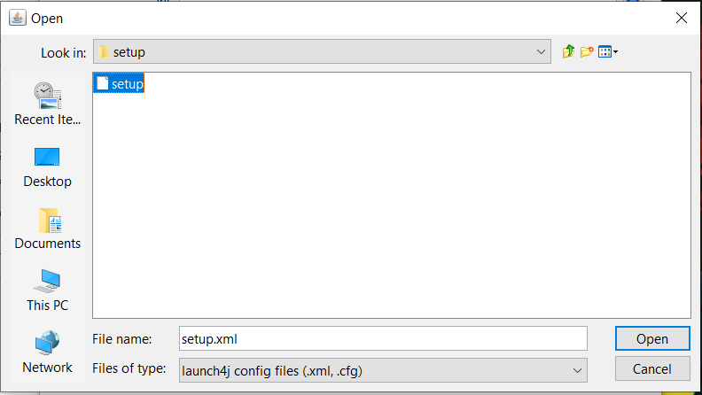

1. Update Output file and Jar to match desired output.  
   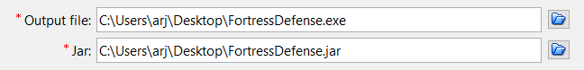
2. Click Build Wrapper.  
   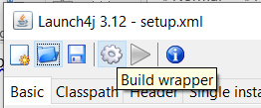

Using Inno Setup to wrap .exe in wizard.

1. Open Inno Setup and click “Open an existing script file.” Click “More Files” then click OK.  
   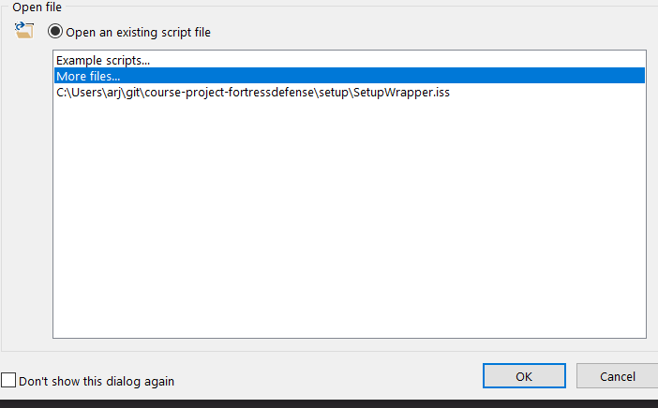
2. Navigate to the repository in the file explorer and go to the setup folder. Open SetupWrapper.iss.  
   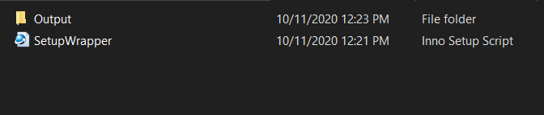
3. Update the source file for the .exe to the location of where the .exe file was generated from the last step.  
   
4. Click Compile.  
   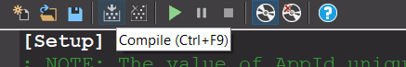
5. The installer will be written to Output folder inside the Setup folder in the repository.

